Chapter AA Shares Fond Memories of Carolyn
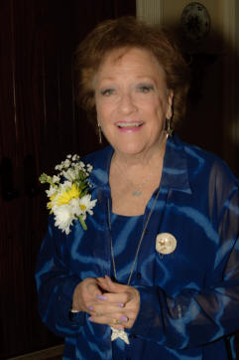
Carolyn Jordan became a P.E.O. on December 9, 1952 in Chapter CO, Houston, Texas. Anyone who met Carolyn knew what P.E.O. is. Carolyn was P.E.O. from her head to her toes. She probably had more jewelry with stars than anyone in the state. She had clothes with stars on them and carried bags purchased from the back of the P.E.O. RECORD that indicated she was a P.E.O. She didn’t just wear stars and carry these bags to P.E.O. She took them everywhere. Sally Sorocak met Carolyn at a Presbyterian Church meeting that Carolyn was in charge of. When Sally noticed the blue bag that Carolyn had her material in, according to Sally she “almost jumped over the table” to get to Carolyn.

Carolyn was a member of six P.E.O. chapters—CO, TX; H, MD; GN, KS; C, LA; F & AA, AL. She held the Consent to Select the Charter List for Chapter AA and served as its first president. Carolyn also served as Chapter AA’s vice president several times and guided Chapter AA through their first 21 years. Carolyn served seven years on the Alabama State Board and served as president in 1991-92. She attended her first International Convention in Winnipeg and never missed another one until her death on July 7, 2015. She had already made reservations to attend the convention in Indianapolis in October.

Carolyn rarely missed a chapter meeting, but when she did it was for the other two passions of her life—her church and her family. She was an elder in the Presbyterian Church and served on all levels of the church in Presbyterian women. She was also active in Church Women United serving as the Birmingham Unit’s president at the time of her death. She was active in the Panel of American Women (Interracial/Interfaith group), and the National Conference of Christians and Jews.

Carolyn’s husband, J. Irwin Jordan, Jr.died November 8, 1986. Because of Irv, Carolyn always wore purple and replaced the star jewelry with Texas Aggie jewelry on fall Saturdays when A&M was playing. Her children are Dr. Michael Jordan, Carol Jordan, and Dr. Bradley Jordan. She had three grandchildren, Lara, Emil, and Nico. There was hardly a P.E.O. meeting where Carolyn did not have something to tell about the accomplishments of one of her children or grandchildren. Carolyn often said that she was the mother of THE Michael Jordan, the basketball player being the other Michael Jordan.

Chapter AA as well as P.E.O. in Alabama will miss Carolyn’s starry sparkle and her loving spirit. We are sure that she has all the P.E.O.s in heaven organized as well as the Presbyterians.

